**Quick Mix**

COSC 412 Individual Project

Ryan Garner

Towson University

Rebecca Broadwater

COSC 412 Fall 2020

Table of Contents

Part 1: **Introduction ..................................................................................................................... 3**

1.1 Project Overview ........................................................................................................... **3**

1.2 Project Deliverables ....................................................................................................... **3**

1.3 Evolution of the SPMP ................................................................................................... **3**

1.4 Reference Materials ....................................................................................................... **3**

1.5 Definitions and Acronyms .............................................................................................. **3**

Part 2: **Project Organization**

2.1 Process Model ............................................................................................................... **4**

2.2 Organizational Structure ................................................................................................. **4**

2.3 Organizational Interface ................................................................................................. **4**

2.4 Project Responsibilities .................................................................................................. **4**

Part 3: **Managerial Process**

3.1 Management Objectives and Priorities ............................................................................. **5**

3.2 Assumptions, Dependencies, and Constraints …........................................................ **5**

3.3 Risk Management .......................................................................................................... **5**

3.4 Monitoring and Controlling Mechanisms ......................................................................... **5**

3.5 Staffing Plan …........................................................................................................... **5**

Part 4: **Technical Process**

4.1 Methods, Tools, and Techniques ..................................................................................... **6**

4.2 Software Documentation ................................................................................................ **6**

4.3 Project Support Functions ............................................................................................... **6**

Part 5: **Description of Work Packages**

Work Breakdown Structure (WBS) ....................................................................................... **7**

Project Schedule .................................................................................................................. **7**

**Part 1: Introduction**

1.1 Project Overview

This will be a website where the user inputs the types of liquors and alcohols that they have available to them (of course there will be an age verification box to ensure that the user is above 21). The website will then take the inputs from the user and go through a database of simple and easy to make mixed drinks that include the liquors that the user has and give the recipe for the drink that the user chooses. The website will also be able to categorize the different types of drinks based on the taste and mixers (Ex: if it’s mixed with pineapple, orange juice, seltzer water, etc..).

1.2 Project Deliverables

Repository – 10/16/2020

SPMP – 10/16/2020

Final Presentation – 12/07/2020

1.3 Evolution of the SPMP

The original SPMP will be the first time the customer will see the entire product laid out which will likely lead to drastic changes so that the result can be exactly what the customer has envisioned.

1.4 Reference Materials

N/A

1.5 Definitions and Acronyms

Database: A collection of data which will be used for holding user's personal information along with their favorited drinks and history of drinks viewed

**Part 2: Project Organization**

2.1 Process Model

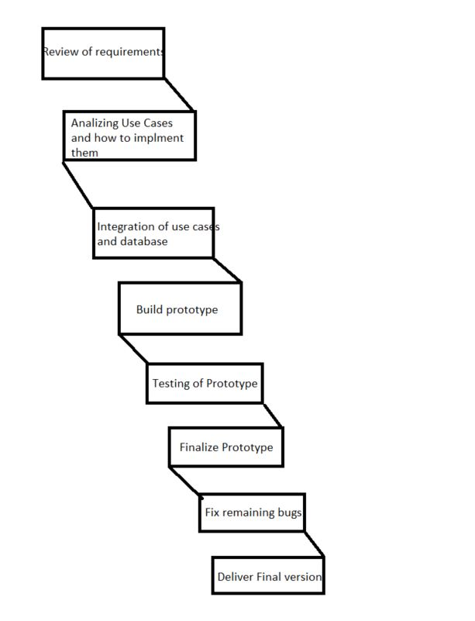

2.2 Organizational Structure

It’s pretty simple as this is an individual project.

2.3 Organizational Interfaces

GitHub

2.4 Project Responsibilities

I will be handling all operations myself

**Part 3: Managerial Process**

3.1 Management Objectives and Priorities

It is my individual responsibility to keep track of my work and stick to the schedule

3.2 Assumptions, Dependencies, and Constraints

This project is under a time constraint, it must be completed by November 30th by midnight

3.3 Risk Management

Risks include making time to work on project with things like work and school.

3.4 Monitoring and Controlling Mechanisms

Updates on the project will be provided via the link to its GitHub. This can be checked at any time.

3.5 Staffing Plan

The project will be led and developed by myself.

**Part 4: Technical Process**

4.1 Methods, Tools, and Techniques

Github, HTML, Javascript, CSS, Database with SQL. Possibly using a cms - Wordpress

4.2 Software Documentation

The documentation plan is to update the SPMP with all updates as needed, ensuring that the revision sheet is updated as well. Anything that does not fit into the SPMP will be written up on a separate word document and added to the repository.

4.3 Project Support Functions

Quality assurance will be guaranteed by having consistent tests to make sure progress and plans continue to align with my vision.

**Part 5: Description of Work Packages**

5.1 Work Breakdown Schedule (WBS)

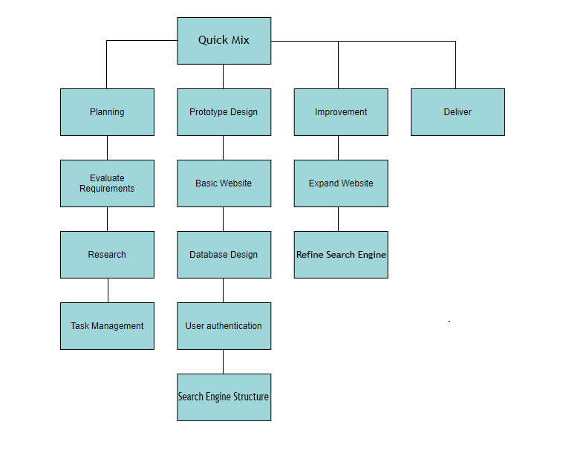

5.2 Project Schedule

Timeline:

